Pastor’s Corner
In March the Church calendar celebrates two saints- David and Patrick. David was a 6th Century monk, renowned as a preacher and teacher. His eloquence in speaking out against false teaching led to his becoming a senior leader in the Welsh Church.
Patrick was taken by Irish raiders in the 5th Century and held as a slave. After he escaped and returned home, a vision called him to serve as a missionary in Ireland. He spent the rest of his life sharing the Gospel with the people who had once held him captive.
These men are called saints for the work they did for God, but in truth ‘saint’ has the same root as ‘sanctified’ or ‘holy,’ which the Bible uses to refer to all of God’s people. In fact, Paul can even use the title to refer to the Christians in Corinth, a Church famous for how wrong they so often got it.
He can call them, “those sanctified in Christ Jesus and called to be his holy people.” [1 Cor 1:2] Wherever we find ourselves, however wrong we’ve got it, God’s people are still a part of this timeless family of faith- there is a place for us at the table alongside David and Patrick.
What’s On
Monday
- Prayer meeting- 7pm (alternate weeks)

Tuesday
- Connect group at Church- 10am
- Connect group at Jon & Jayne’s- 7.30pm (alternate weeks)

Wednesday
- Connect group at Dave & Gill’s- 7.30pm
- Connect group at Gareth and Nem’s- 7.30pm
- Connect group at Church- 7pm

Friday
- Parent and Tots- 9.30am
- The Ark Kids Club- 6:15-7:45pm (alternate weeks)
- NYI- 6.30-7.30pm

Sunday
- Family worship- 10.30am
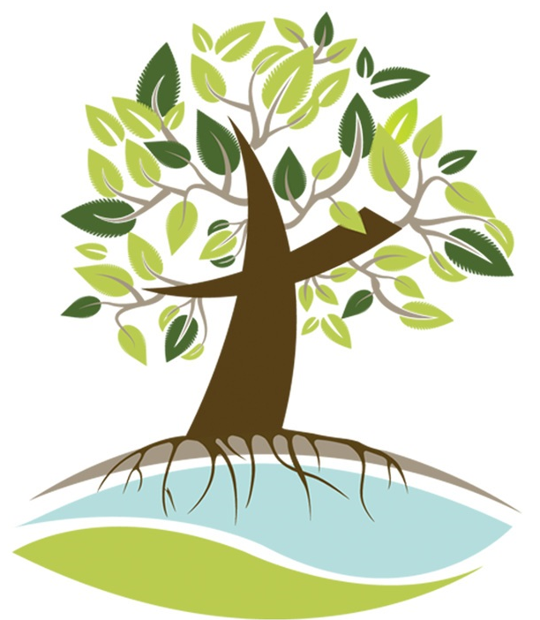

Llay Community
Church of the Nazarene

Helping people find life in all its fullness

March

Who We Are

We are part of a worldwide Church family which exists to make Christ-like disciples.
As a local Church, we are participants in the work of Jesus who said, I have come that they may have life, and have it to the full. [John 10:10]
We believe that we are planted in Llay, for Llay- we want to be servants of our local community, with the village in the heart of the Church, and the Church in the heart of the village.
We are locally focused, but globally minded. Our village has first claim upon our ministry, but we want to make an impact on this entire generation, even if we never see its fruit this side of Heaven.
We aim to grow deeper through discipleship, enabling our people to know God better and love God more, and grow wider, helping everyone to realise that there is a seat for them at God’s table.
And we want you to know that you are so very welcome here!
Rotas

Welcoming
3rd- Fay & Grant
10th- Amy & Andrew
17th- Austin & Clive
24th- Glenys & Dave
31st- Gaynor & Ian

Refreshments
3rd- Pat & Clive
10th- Mel & Austin
17th- Glenys & Lily
24th- Anwen & Andrew
31st- Jean & Tony

Sunday school
3rd- Sarah G
10th- Emma
17th- Gemma
24th- Gill
31st- Sarah S

Offering counting
Fay & Gareth
January tithes & offerings
Main fund- £2,747.85
Announcements

Community Bible Experience
Our reading plan starts on the 5th March and will continue throughout Lent and shortly after. If you haven’t registered, it’s not too late!
Digital Literacy Course
We’re hosting a free digital skills course for over 50s. It will run for five weeks, starting on the 13th March, from 2-4pm. Please speak with Pastor David if you or anyone you know would like to register!
Movie Night
16th March, 6pm- this month we’re watching Wreck it Ralph 2: Ralph Breaks the Internet. Come along and bring some friends!

Word and Table
17th March, 9:30am- everyone is welcome to our early morning liturgical service as we celebrate the Lord’s Supper together.
-----------------------------------------------------------------------------
Contact Details

Pastor David Gilmour
078 350 22193
Dgilmour325@gmail.com

